Point on a Line
# Source: AI Source: Provided by: [Data Path: Persons Table -> ID Column: 1, Name_En Column: Motasem Essam] -> From: [ChatGPT] on [7/25/2026]
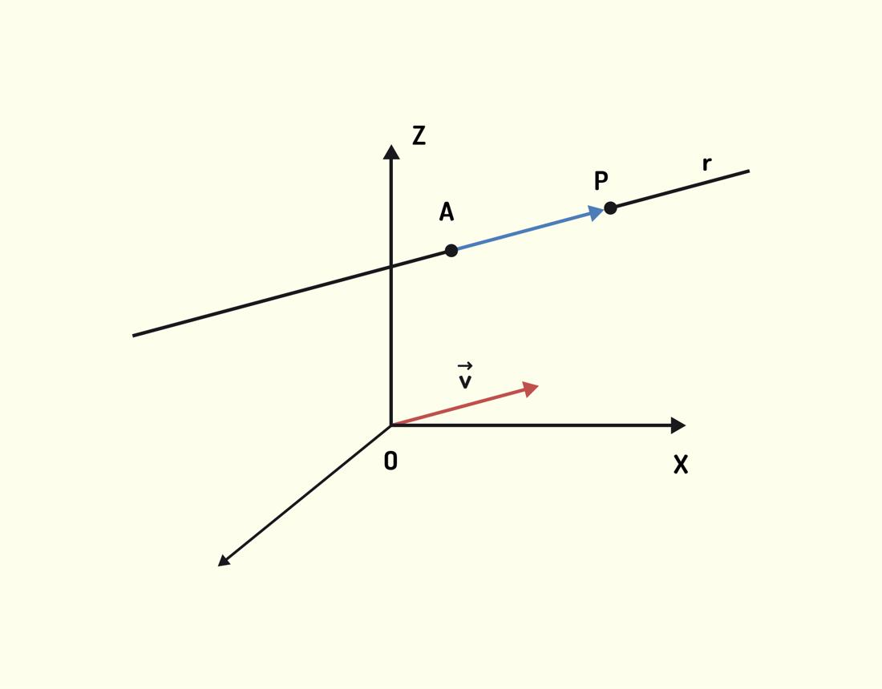
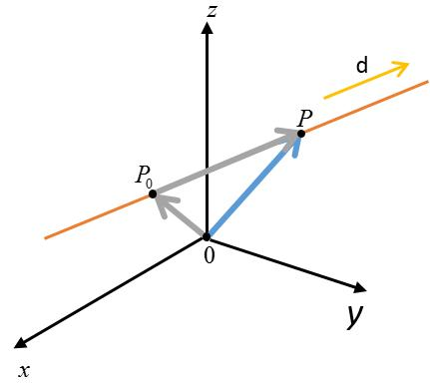
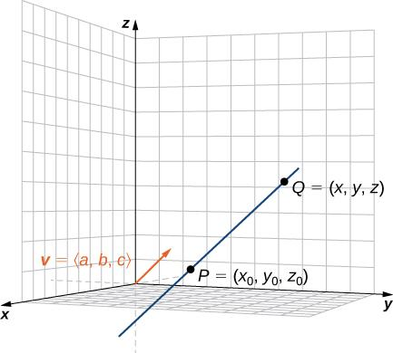

Definition
# Source: AI Source: Provided by: [Data Path: Persons Table -> ID Column: 1, Name_En Column: Motasem Essam] -> From: [ChatGPT] on [7/25/2026]
A point on a line in Solid Geometry is a point whose position satisfies the equation defining a particular straight line in three-dimensional space.
The line may extend in any direction through space. A point belongs to the line if it lies exactly on that line, regardless of whether the line is parallel to a coordinate axis or passes through a coordinate plane.

Simple Definition
# Source: AI Source: Provided by: [Data Path: Persons Table -> ID Column: 1, Name_En Column: Motasem Essam] -> From: [ChatGPT] on [7/25/2026]
A point on a line is a location that lies exactly on a straight line in three-dimensional space.
For example, if a line passes through points $A$ and $B$, any point $P$ lying on that line is a point on the line.
$$A ⟶ P ⟶ B$$
The arrows here illustrate the arrangement of points along a line, not necessarily its endpoints.

Key Characteristics
# Source: AI Source: Provided by: [Data Path: Persons Table -> ID Column: 1, Name_En Column: Motasem Essam] -> From: [ChatGPT] on [7/25/2026]
- Collinearity: A point on a line is collinear with the other points on that line.
- One-dimensional relationship: A line is one-dimensional, even when embedded in three-dimensional space.
- Infinite extent: A geometric line extends infinitely in both directions.
- Coordinate representation: A point is represented by three coordinates $\left(x,y,z\right)$.
- Equation satisfaction: The point's coordinates satisfy the line's mathematical representation.
- No thickness: A point and a line are ideal geometric objects without physical thickness.

Types of Points on Lines in Solid Geometry

1. Point on a Coordinate-Axis Line
# Source: AI Source: Provided by: [Data Path: Persons Table -> ID Column: 1, Name_En Column: Motasem Essam] -> From: [ChatGPT] on [7/25/2026]
A point lying on one of the three Cartesian coordinate axes.
Examples:
- $P=\left(a,0,0\right)$: on the $x$-axis.
- $P=\left(0,b,0\right)$: on the $y$-axis.
- $P=\left(0,0,c\right)$: on the $z$-axis.
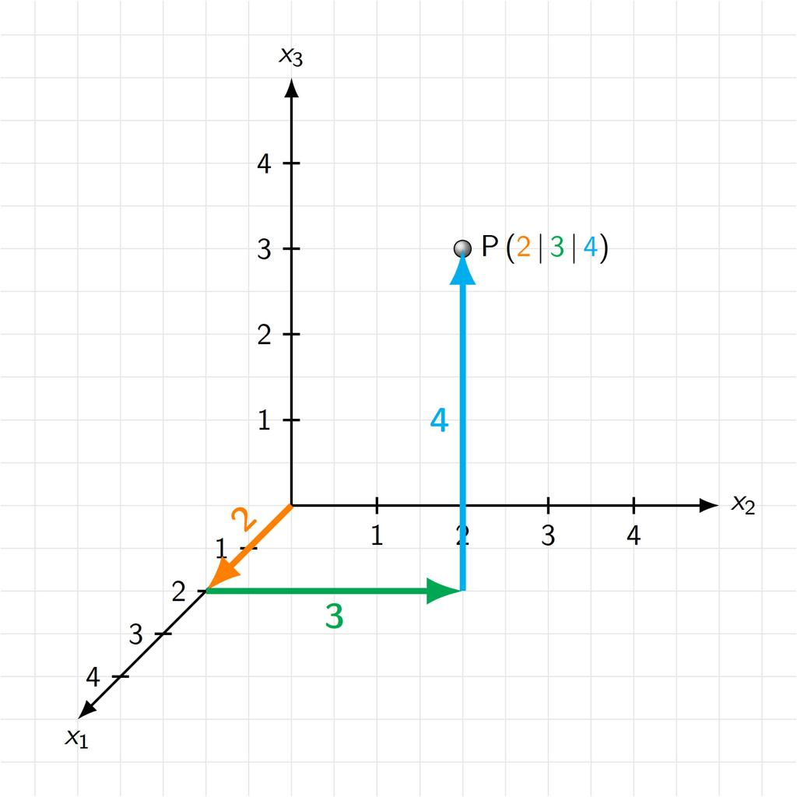

2. Point on a General Spatial Line
# Source: AI Source: Provided by: [Data Path: Persons Table -> ID Column: 1, Name_En Column: Motasem Essam] -> From: [ChatGPT] on [7/25/2026]
A point lying on a straight line that may be inclined to all three coordinate axes.
Example: $P$ lies on a line whose direction vector is $\left(1,2,3\right)$.
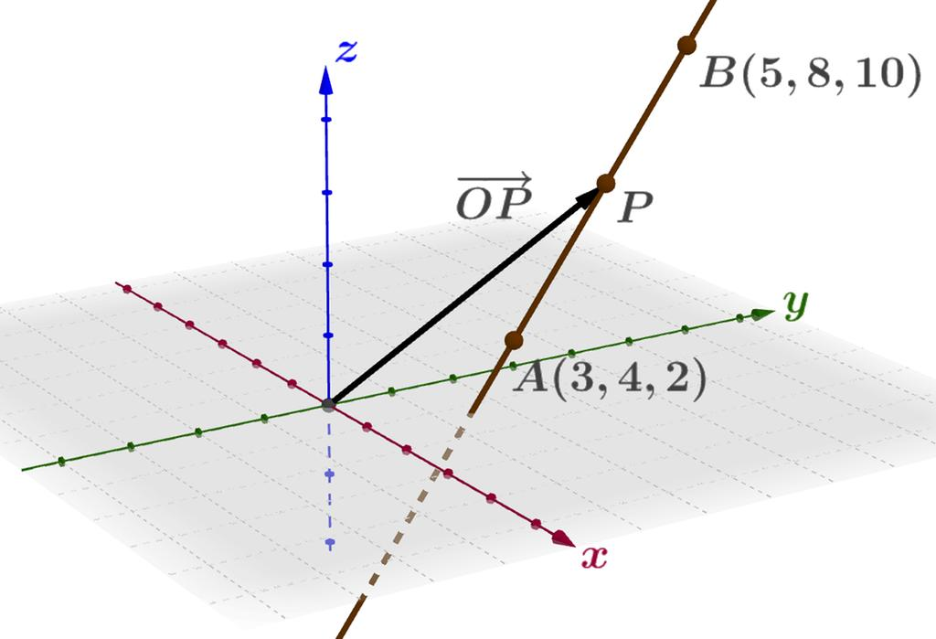

3. Point Between Two Points on a Line
# Source: AI Source: Provided by: [Data Path: Persons Table -> ID Column: 1, Name_En Column: Motasem Essam] -> From: [ChatGPT] on [7/25/2026]
A point located between two other points along the same line.
If $P$ lies between $A$ and $B$, then
$$AP+PB=AB$$
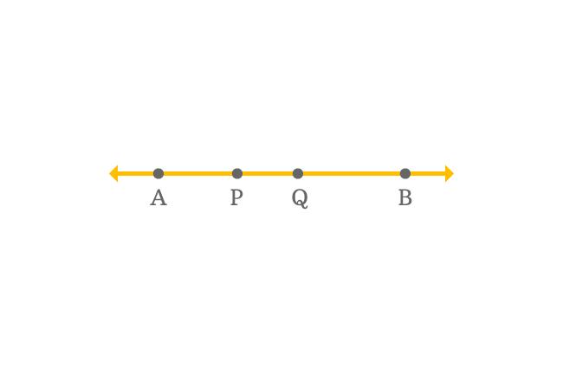
This relationship holds when $P$ is between the endpoints.

4. Point on a Line Segment
# Source: AI Source: Provided by: [Data Path: Persons Table -> ID Column: 1, Name_En Column: Motasem Essam] -> From: [ChatGPT] on [7/25/2026]
A point that belongs to the finite part of a line between two endpoints, including the endpoints themselves.
Example: The midpoint of a segment is a point on that segment.
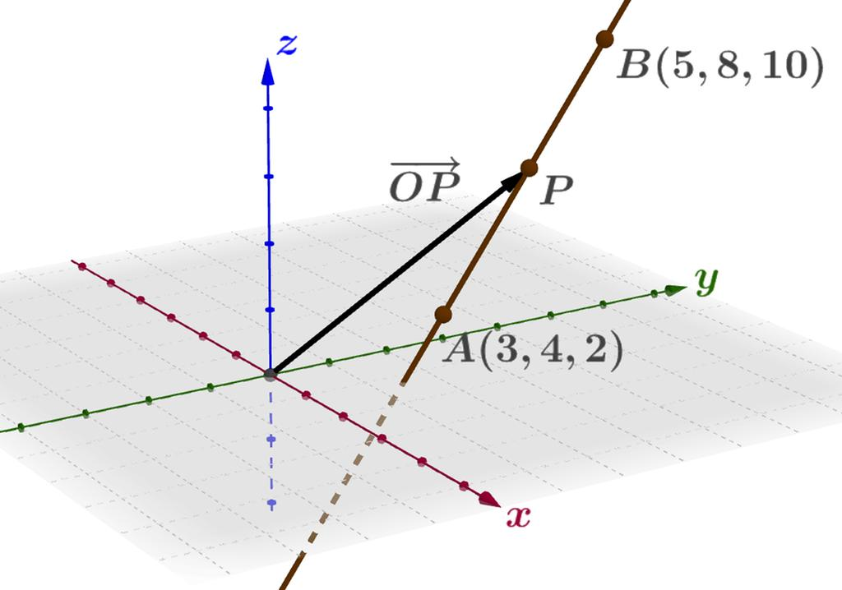

5. Point on a Ray
# Source: AI Source: Provided by: [Data Path: Persons Table -> ID Column: 1, Name_En Column: Motasem Essam] -> From: [ChatGPT] on [7/25/2026]
A point belonging to a ray that starts at an endpoint and extends infinitely in one direction.
Example: For ray $\overset{→}{AB}$, both $A$ and $B$ belong to the ray.
These are useful positional categories, not mutually exclusive types. A point can simultaneously lie on a spatial line, a line segment, and a ray, depending on the objects being considered.

Mathematical Representation

1. Parametric Equation of a Line
# Source: AI Source: Provided by: [Data Path: Persons Table -> ID Column: 1, Name_En Column: Motasem Essam] -> From: [ChatGPT] on [7/25/2026]
A line in three-dimensional space can be represented as
$$\boxed{r=a+td}$$
where:
- $a=\left(x_{0},y_{0},z_{0}\right)$ is a point on the line.
- $d=\left(u,v,w\right)$ is a nonzero direction vector.
- $t$ is a real parameter, $t∈R$.
In coordinate form,
$$\begin{aligned}x&=x_{0}+tu \\ y&=y_{0}+tv \\ z&=z_{0}+tw\end{aligned}$$
A point $P=\left(x,y,z\right)$ lies on the line if there is a single real value of $t$ that satisfies all three equations.

2. Example
# Source: AI Source: Provided by: [Data Path: Persons Table -> ID Column: 1, Name_En Column: Motasem Essam] -> From: [ChatGPT] on [7/25/2026]
Consider the line
$$\begin{aligned}x&=1+t \\ y&=2+2t \\ z&=3+3t\end{aligned}$$
For $t=2$,
$$x=3, y=6, z=9$$
Therefore,
$$\boxed{P=\left(3,6,9\right)}$$
is a point on the line.
For $t=0$, the point is $\left(1,2,3\right)$, which is also on the line.

Determining Whether a Point Lies on a Line
# Source: AI Source: Provided by: [Data Path: Persons Table -> ID Column: 1, Name_En Column: Motasem Essam] -> From: [ChatGPT] on [7/25/2026]
To determine whether $P=\left(x,y,z\right)$ lies on a line, substitute its coordinates into the line's equations and check whether one common parameter value satisfies all of them.
Example: Consider the line
$$\left(x,y,z\right)=\left(1,2,3\right)+t\left(1,2,3\right)$$
Does $P=\left(3,6,9\right)$ lie on it?
The coordinate equations give
$$t=3-1=2$$
$$t=\frac{6-2}{2}=2$$
$$t=\frac{9-3}{3}=2$$
All three coordinates give $t=2$. Therefore, the point lies on the line.
If the equations produce inconsistent values of $t$, the point does not lie on that line.

Finding the Midpoint of Two Points on a Line
# Source: AI Source: Provided by: [Data Path: Persons Table -> ID Column: 1, Name_En Column: Motasem Essam] -> From: [ChatGPT] on [7/25/2026]
If $A=\left(x_{1},y_{1},z_{1}\right)$ and $B=\left(x_{2},y_{2},z_{2}\right)$ are points on a line, the midpoint $M$ of segment $AB$ is
$$\boxed{M=\left(\frac{x_{1}+x_{2}}{2},\frac{y_{1}+y_{2}}{2},\frac{z_{1}+z_{2}}{2}\right)}$$
For example, if $A=\left(0,2,4\right)$ and $B=\left(4,6,8\right)$, then
$$M=\left(2,4,6\right)$$
The midpoint lies on the same line segment.

Point on a Line vs. Related Concepts
# Source: AI Source: Provided by: [Data Path: Persons Table -> ID Column: 1, Name_En Column: Motasem Essam] -> From: [ChatGPT] on [7/25/2026]
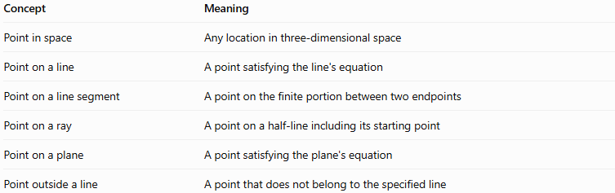
Concept | Meaning
Point in space | Any location in three-dimensional space
Point on a line | A point satisfying the line's equation
Point on a line segment | A point on the finite portion between two endpoints
Point on a ray | A point on a half-line including its starting point
Point on a plane | A point satisfying the plane's equation
Point outside a line | A point that does not belong to the specified line

Applications
# Source: AI Source: Provided by: [Data Path: Persons Table -> ID Column: 1, Name_En Column: Motasem Essam] -> From: [ChatGPT] on [7/25/2026]
- Coordinate geometry: Determining whether points are collinear.
- Architecture: Locating points along beams, edges, and structural lines.
- Engineering: Defining points along axes and three-dimensional components.
- Computer graphics: Calculating positions along 3D paths.
- Physics: Representing positions along a trajectory or direction line.
- Navigation and robotics: Computing positions along straight routes and movement paths.

Key Points
# Source: AI Source: Provided by: [Data Path: Persons Table -> ID Column: 1, Name_En Column: Motasem Essam] -> From: [ChatGPT] on [7/25/2026]
- A point on a line belongs exactly to that line.
- A spatial point is represented by $\left(x,y,z\right)$.
- A line in space can be expressed using a point and a direction vector.
- A point lies on a parametric line if one common parameter satisfies all three coordinate equations.
- A point between two endpoints satisfies $AP+PB=AB$.
- A line segment and a ray are restricted parts of a line.
- A point may belong to several geometric objects at once.

Conclusion
# Source: AI Source: Provided by: [Data Path: Persons Table -> ID Column: 1, Name_En Column: Motasem Essam] -> From: [ChatGPT] on [7/25/2026]
A point on a line in Solid Geometry is a location that satisfies the equation of a straight line in three-dimensional space. It can be identified using Cartesian coordinates, parametric equations, and relationships between collinear points. This concept is fundamental to understanding line segments, rays, spatial distances, and the relationships among geometric elements in three dimensions.

